Universal Single-Use Bronchoscope Tracker
Updated Engineering Plan and Design Blueprint v4
June 30, 2026 | Nonclinical simulation prototype
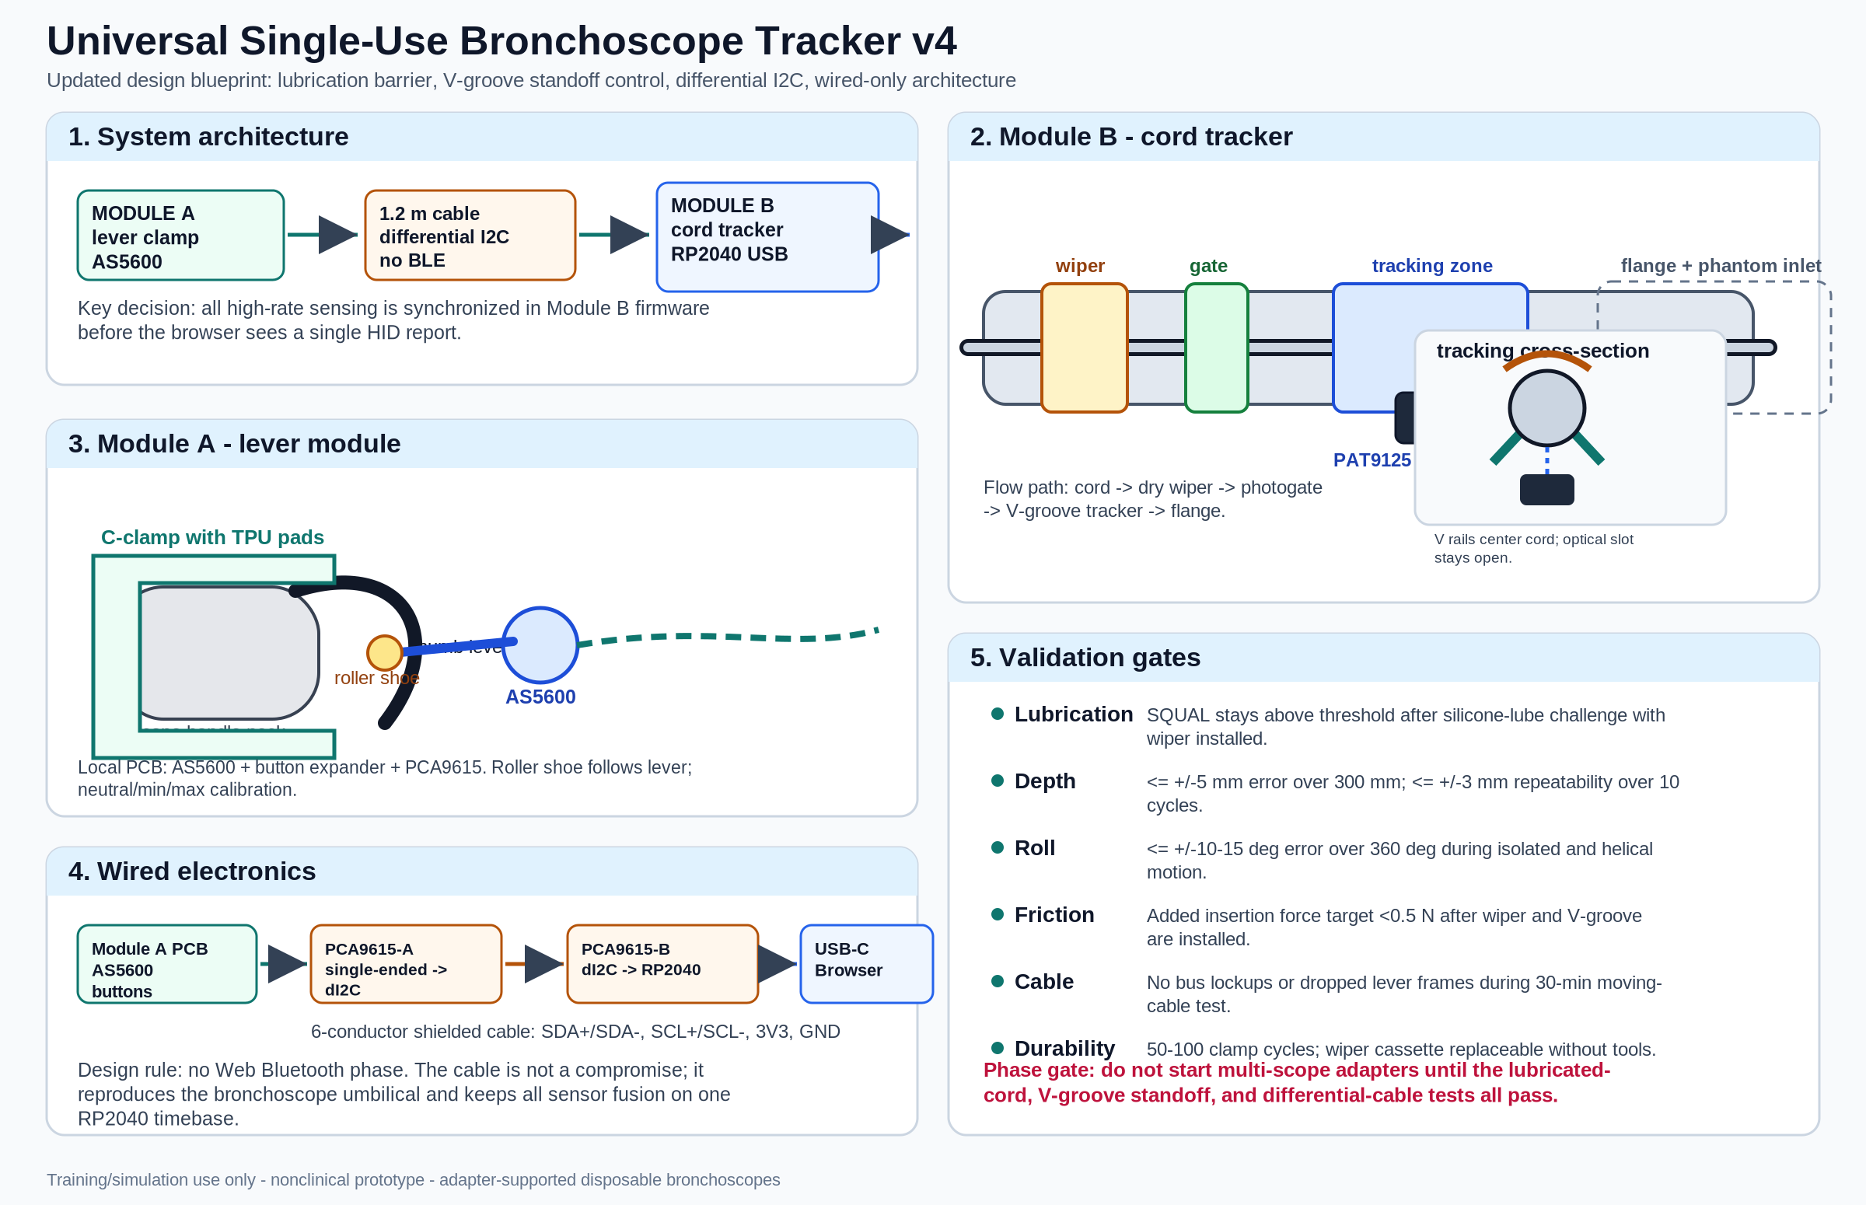
Figure 1. v4 blueprint showing the wired architecture, clamshell Module B, wiper zone, V-groove tracking saddle, and differential I2C cable.

0. What changed in v4
Area | Previous direction | v4 decision
Module B lubricant handling | Rely on SQUAL warning and cleaning | Add replaceable proximal felt/foam wiper ring before photogate and sensor.
Module B standoff | Snug bore plus leaf spring | Use diameter-specific V-groove tracking saddle around the optical aperture with compliant opposing cap.
Module A cable | Direct single-ended I2C over ~1.2 m, PCA9615 fallback | Make PCA9615 differential I2C the default wired architecture.
Wireless lever module | Possible Phase 4 BLE option | Remove from roadmap; keep all sensing wired and synchronized.
Compatibility language | Any disposable bronchoscope | Adapter-supported disposable bronchoscopes, validated model by model.
Module B geometry | Pass-through bore | Split clamshell tracker with swappable insert cassette, wiper cassette, and flange.

1. One-sentence concept
A two-module, clip-on, open-hardware training controller that lets a disposable bronchoscope act as a three-degree-of-freedom simulator input device without modifying the scope: Module A tracks thumb-lever flexion and Module B tracks insertion depth and roll at the cord.

2. Realistic development target
The realistic v1 target is a reliable adapter-supported bronchoscopy simulator controller, first validated on one disposable bronchoscope family, then expanded through parametric adapters. The project should not claim true universality until each scope family has a validated adapter, insert, and calibration profile.

3. Non-negotiable design rules
1. Training-only use: simulation, education, and bench validation only; not for patient care or clinical navigation.
2. No scope modification: no adhesive, drilling, magnets attached to the scope, disassembly, or interference with real suction/working-channel controls.
3. Adapter-supported compatibility: v1 is validated on selected disposable bronchoscopes; additional scopes require published adapter profiles and repeat validation.
4. Wired baseline: the lever module connects through a flexible cable using differential I2C.
5. Lubricant-tolerant optical zone: include a replaceable proximal wiper and SQUAL-based quality gate.
6. Controlled standoff: center the cord with a V-groove saddle and compliant cap, not a loose bore.
7. Browser-native runtime: USB HID gamepad for runtime, CDC/Web Serial or CLI for calibration.
8. Objective phase gates: no multi-scope expansion until tracking, standoff, friction, and cable stability pass bench testing.

4. System architecture
MODULE A - LEVER MODULE -> 1.2 m differential I2C cable -> MODULE B - CORD TRACKER
C-clamp + AS5600 + buttons PCA9615 on both ends wiper + gate + V-groove + optical sensor + RP2040 USB
Degree of freedom | Sensed by | Location | Principle
Tip flexion | AS5600 magnetic encoder | Module A hinge | Follower-arm angle maps to thumb-lever angle.
Insertion depth | Optical tracking sensor | Module B cord saddle | Optical Y counts after 2x2 calibration matrix.
Roll | Optical tracking sensor | Module B cord saddle | Optical X counts after 2x2 calibration matrix.
Buttons | Tactile switches | Module A body | Simulation controls; real suction button untouched.

All high-rate data are fused in Module B firmware and emitted as one synchronized USB HID report. This avoids browser-side timing mismatch between independent BLE and USB streams.

5. Module A - lever module blueprint

5.1 Mechanical design
Module A is a printed clamp that attaches to the bronchoscope handle neck without altering the scope. It carries its own hinge and follower arm. The follower arm touches the thumb lever through a small low-friction roller or rounded shoe.
- Two-piece C-clamp with TPU or silicone pads.
- Captive M3 thumb screw or over-center latch.
- Hard datum surface for repeatable clamp placement.
- Follower arm pivot on a steel or shoulder-screw axle.
- Light torsion spring to maintain lever contact.
- Roller or polished rounded shoe with 1-2 mm compliance.
- Optional simulator buttons on the module body.
- Cable strain relief directed toward the scope umbilical/cord path.

5.2 Sensor and calibration
The follower-arm hinge uses an AS5600 magnetic rotary sensor and a diametric magnet embedded in the follower hub. Calibration captures neutral, full up, full down, and an optional midpoint check to detect shoe slippage or clamp misplacement.

5.3 Module A electronics
Subcomponent | Purpose
AS5600 | Lever angle measurement.
Diametric magnet | Rotates with follower arm.
PCA9615-A | Converts local single-ended I2C to differential I2C for cable.
MCP23008/PCF8574 or similar | Reads optional buttons over the same local I2C segment.
ESD/TVS protection | Cable robustness.
JST-GH or locking connector | Strain-resistant detachable cable.

6. Module B - cord tracker blueprint
Module B is the critical module. v4 changes it from a simple pass-through bore into a split clamshell tracker with controlled lubrication handling, focal distance, and cable management.

6.1 Zone layout
1. Wiper zone: replaceable slotted felt or high-density foam ring to remove silicone lubricant, condensation, and phantom residue before the optical window.
2. Zero/gate zone: IR photogate or optical interrupter for tip passage/zero sanity check; manual zero at the flange plane remains available.
3. Tracking zone: diameter-specific insert cassette with V-groove saddle around the optical window, compliant top cap, and optical sensor below.
4. Mounting flange: standard interface to phantom inlet, manikin adapter, or desk stand.

6.2 Lubrication barrier
The wiper is now a baseline component. The tracker must maintain adequate SQUAL after a realistic silicone-lubricant challenge; a software warning alone is insufficient.
- Tool-free sliding cassette holding a replaceable C-shaped felt or foam ring.
- Slotted geometry so it can be replaced without threading over the distal tip.
- Ring ID approximately cord OD minus 0.1 to 0.2 mm for gentle contact, tuned by material.
- Thickness 3-5 mm in the direction of travel.
- Spare wipers stored in the kit.
- Firmware counter reminding users to replace the wiper after a defined number of sessions or if SQUAL falls.

6.3 V-groove standoff control
The insert should use two polished rails forming a shallow V around the optical aperture. The cord sits in the V, while a compliant opposing cap supplies gentle downward force. The V-groove should be interrupted around the optical aperture rather than forming an opaque floor.
Parameter | Starting value
Insert family | One cassette per cord OD range.
Cord radial clearance | Cord OD + 0.2 to 0.4 mm outside the tracking saddle.
V-groove angle | 90-120 degrees, test both.
Optical slot width | 1.5-2.5 mm, sensor dependent.
Compliant cap travel | 0.5-1.5 mm.
Added insertion force | Target <0.5 N after wiper + V-groove are installed.
Insert material | PETG/ASA body; polished PTFE/POM or resin insert surface if friction is high.

6.4 Clamshell and insert strategy
- Hinged or fully separable two-piece body.
- Captive latch or thumb screw.
- Swappable insert cassette for each cord diameter family.
- Swappable wiper cassette independent of the insert cassette.
- Hard stop defining the flange/zero plane.
- Cable exit and USB port protected from hand contact and phantom moisture.
- Drainage or removable cover so residue does not pool over the optical sensor.

7. Optical sensor strategy
The PAT9125 remains the preferred clean open-hardware candidate if it passes Phase 0. v4 treats optical tracking as environment-dependent rather than guaranteed.
Path | When to use | Comment
PAT9125 single sensor | Default if SQUAL and accuracy pass wet/dry tests. | Lowest cost and simplest open design.
PMW3360 or similar | Use if PAT9125 fails on cord finish or speed. | Better performance but more firmware/licensing complexity.
Dual optical sensors 90 degrees apart | Use if single-sensor cross-coupling remains high. | Adds cost and alignment burden.
Wheel encoder cassette | Use if optical tracking fails after lubrication mitigation. | Less elegant, but robust and publishable fallback.

Firmware should continuously track SQUAL or equivalent surface-quality metric, delta count saturation, dropout frequency, unexpected jumps, and calibration-motion correlation.

8. Electronics and signal integrity

8.1 Default wired architecture
Single-ended I2C over a moving 1.2 m cable is no longer the baseline. The AS5600 and button expander communicate locally to PCA9615-A in Module A. The cable carries differential I2C to PCA9615-B in Module B, which connects to the RP2040.
AS5600 + buttons -> local I2C -> PCA9615-A -> differential cable -> PCA9615-B -> RP2040
Conductors | Function
Twisted pair 1 | SDA+ / SDA-.
Twisted pair 2 | SCL+ / SCL-.
Power | 3.3 V or 5 V, selected by PCB design.
Ground/shield | Ground reference and shield termination.

8.2 Module B main PCB
Component | Purpose
RP2040/Pi Pico or custom RP2040 board | Sensor fusion, USB HID, CDC serial.
PCA9615-B | Differential I2C receiver/transceiver for Module A.
PAT9125 or fallback optical sensor | Cord motion tracking.
IR photogate | Tip passage/zero sanity check.
Calibrate button | Local zero/calibration mode.
RGB LED | Tracking OK, low SQUAL, cable fault, calibration.
USB-C | Power and data.
Optional EEPROM | Hardware revision and calibration defaults.

9. Firmware design
- Optical sensor read: 500-1000 Hz target.
- Lever sensor read: 250-500 Hz target over differential I2C.
- Fusion/report loop: 125-250 Hz HID report rate.
- CDC serial: raw counts, SQUAL, matrix values, diagnostics.

9.1 Calibration model
[ depth_mm ] [ a b ] [ dy_counts ]
[ roll_deg ] = [ c d ] [ dx_counts ]
1. Pure 100 mm insertion using ruler jig.
2. Pure 360 degree roll using roll jig.
3. Combined helical motion to check cross-coupling.
4. Lubricated-cord repeat after wiper pass.

9.2 HID report design
HID axis | Meaning
Axis 0 | Flexion, -1 to +1.
Axis 1 | Depth normalized to selected airway path length.
Axis 2 | sin(roll).
Axis 3 | cos(roll).
Buttons | Simulator action buttons.

9.3 Fault handling
- Low SQUAL: freeze optical accumulation only if dropouts exceed threshold; otherwise continue with warning.
- Cable fault: reinitialize lever I2C bus and log event.
- Stuck I2C bus: firmware attempts bus recovery, then requests reconnect if needed.
- Calibration mismatch: reject profile if helical validation exceeds error threshold.

10. Web app integration
Runtime remains USB HID/Gamepad. Calibration uses Web Serial on supported desktop browsers, with a CLI fallback for locked-down systems. v4 removes Web Bluetooth. The wired lever cable mimics a bronchoscope umbilical, avoids battery management, avoids browser BLE compatibility problems, and keeps all sensor fusion under one timestamped firmware loop.
Component | Purpose
ScopeInputProvider | Abstracts keyboard, gamepad, and hardware scope input.
/hardware setup route | Connect, live bars, SQUAL display, profile selection, calibration.
useScopeInput() hook | Client-only input hook for simulation runtime.
Local profile store | Insert ID, lever calibration, 2x2 matrix, SQUAL thresholds.
Optional cloud profile | Later Supabase storage for classroom kits and competency dashboards.

11. Build phases and exit criteria
Phase | Work | Exit criterion
0 - Bench de-risking | Dry/lubricated cord, wiper, V-groove, lateral torque, helical motion, SQUAL logging. | Depth <= +/-5 mm over 300 mm; roll <= +/-10-15 deg; dropout <1%; lube passes after wiper.
1 - Module B alpha | Clamshell with wiper cassette, V-groove insert, optical board, RP2040. | Insertion and roll drive debug visualizer after wet/dry tests.
2 - Module A alpha | Lever clamp with AS5600, button expander, PCA9615-A. | Stable lever signal during 30-min moving-cable test; no bus lockups.
3 - Integrated HID prototype | Fuse all data into HID gamepad report with calibration UI. | All 3 DOFs drive simulator with perceived latency <30 ms.
4 - Robustness/usability | Attach/detach cycles, wiper replacement cycles, fellow-facing usability. | 50-100 attachment cycles; setup under 2 min; no structural failure.
5 - Adapters/publication | Additional adapters and manuscript package. | Bench validation + face/content validity + reproducible files.

12. Validation plan
Test | Method | Output
Linear depth | 300 mm ruler/linear stage | Error, repeatability, drift.
Roll | Rotary jig, 360/720 degrees | Roll error and wrap behavior.
Helical motion | Simultaneous insertion + roll | Cross-coupling residual after matrix calibration.
Lubrication challenge | Silicone lube and phantom residue | SQUAL, error, dropout with/without wiper.
Friction | Spring scale or force gauge | Added insertion force.
Cable integrity | Moving-cable stress test | Dropped frames, I2C recovery events.
Attach/detach | Repeated mounting cycles | Calibration drift, mechanical wear.

Simulation validity should compare novice, fellow, and attending performance on named-segment navigation tasks, including time, path efficiency, collision rate, branch-selection accuracy, and user-rated realism.

13. Risk register v4
Risk | Current likelihood | Mitigation now in baseline
Lubricant/residue blocks optical tracking | High | Replaceable wiper before photogate/sensor; SQUAL gate; wet testing in Phase 0.
Cord wanders away from focal plane | High | V-groove saddle around aperture with compliant opposing cap.
Optical tracking unreliable on specific cord finish | Medium-high | Test PAT9125 and fallback sensor; wheel-encoder cassette branch.
I2C lever bus unstable over cable | Medium without extender; low with extender | PCA9615 default on both ends; moving-cable stress test.
BLE latency/sync problems | Removed | No wireless phase.
Added friction changes scope feel | Medium | Wiper material testing; V-groove polish/PTFE; force threshold.
Clamp fit varies across scopes | Medium | Parametric adapter library and per-model validation.
Classroom durability | Medium-high | Heat-set inserts, captive fasteners, spare wipers, replaceable insert cassettes.

14. Bill of materials - realistic v4 estimate
Subassembly | Expected prototype cost | At-scale kit target
Module A mechanical parts | $10-20 | $5-10
AS5600, magnet, button expander | $5-8 | $3-5
Module A PCA9615/PCB/connectors | $10-20 | $5-10
Differential cable and strain relief | $8-15 | $4-8
Module B RP2040/USB/status electronics | $10-20 | $6-12
Optical sensor path | $8-20 | $5-12
Module B PCA9615/PCB/connectors | $10-20 | $5-10
Photogate and wiper cassette materials | $5-15 | $2-6
Printed housings/inserts/hardware | $15-30 | $8-15
Total | $81-168 | $43-88

Planning number: $100-180 for early prototypes and $70-100 for a polished educational kit after PCB consolidation and print optimization.

15. CAD and repo package
/hardware
/cad
module_a_lever_clamp.build123d.py
module_b_clamshell_tracker.build123d.py
insert_profiles.yaml
flange_standard.step
/stl
module_a_base/ module_a_shoes/ module_b_body/ v_groove_inserts/ wiper_cassettes/ desk_stand/
/electronics
module_a_pca9615_as5600/ module_b_rp2040_tracker/ wiring_diagrams/ bom.csv
/firmware
platformio/ drivers/ calibration/ releases/uf2/
/web
hardware_setup_route/ useScopeInput/
/docs
build_guide.md calibration_guide.md validation_protocol.md scope_profile_contribution_guide.md

16. Immediate next actions
1. Build a benchtop V-groove optical jig before printing a full enclosure.
2. Test wiper materials using dry, lubricated, and phantom-residue cord conditions.
3. Order two PCA9615 breakout boards or design the small Module A/B PCBs immediately.
4. Remove BLE tasks from the roadmap and issue list.
5. Define the first validated scope family and insert dimensions.
6. Create a validation spreadsheet before running tests so failures become design data rather than anecdotes.

17. Source notes
- User-supplied v2 engineering plan: universal-scope-tracker-plan-v2(1).md.
- ams OSRAM AS5600 product page: https://ams-osram.com/products/sensor-solutions/position-sensors/ams-as5600-position-sensor
- PixArt PAT9125EL public references: https://www.pixart.com/search/%26page%3D1%26keyword%3DPAT9125EL and https://www.epsglobal.com/Media-Library/EPSGlobal/Products/files/pixart/PAT9125EL-TKITPAT9125EL-TKMT.pdf
- NXP PCA9615 product datasheet: https://www.nxp.com/docs/en/data-sheet/PCA9615.pdf
- NXP I2C-bus specification/user manual: https://www.nxp.com/documents/user_manual/UM10204.pdf
- MDN Web Bluetooth API: https://developer.mozilla.org/en-US/docs/Web/API/Web_Bluetooth_API
- MDN Gamepad API: https://developer.mozilla.org/en-US/docs/Web/API/Gamepad_API
- MDN Web Serial API: https://developer.mozilla.org/en-US/docs/Web/API/Web_Serial_API

